Old precedue:

|  |
| --- |
| 1. Switch valve (automatic, no command required) 2. Empty the syringe pump (automatic, no command required) 3. Wait for a signal to start preparing the slug   Create a gas slug in needle seat channel to prevent diffusion, and create a detection space:   1. Move needle in air 2. Draw 20 ul gas from air 3. Move needle into needle seat 4. Eject 20 ul gas into needle seat   Create a gas slug in needle to prevent diffusion:   1. Move needle in air 2. Draw 20 ul gas from air   Prepare the slug:   1. Draw x ul liquid from vial x 2. Wash the needle 3. Repeat step 10-11   Mix the slug:   1. Move the needle into mixing vial 2. Draw and eject 3 times to fully mix the slug   Inject the slug into sample loop:   1. Move the needle into needle seat 2. Send a signal to start an external pump to start pushing slug into sample loop 3. Stop the pump until a slug is detected   Switch valve and move the slug into reaction system:   1. Waiting for switching signal 2. Switch valve 3. Send a signal to notify the reaction system to start pushing slug into the reaction system 4. Wait for slug to be fully pushed out of the sample loop 5. End |

New procedure:

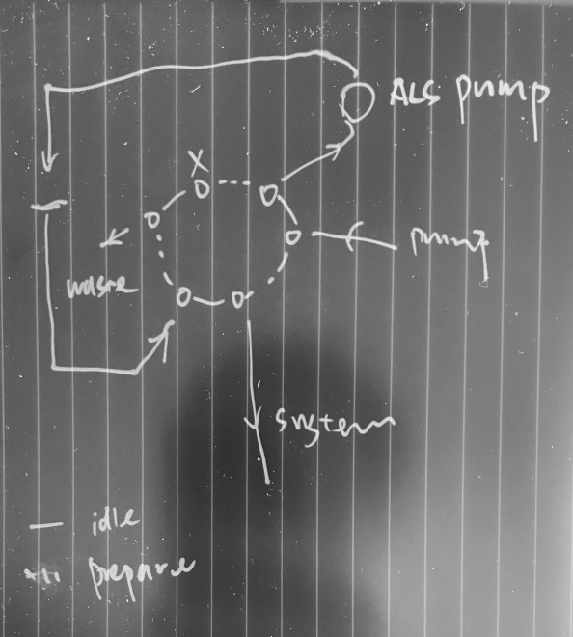

|  |
| --- |
| 1. Re-load the method with DDE command 2. Run sequence with DDE command 3. Switch valve to bypass (automatic, no command required) 4. Empty the ALS syringe pump (automatic, no command required)   Create a gas slug in needle seat channel to prevent diffusion, and create a detection space:   1. Move needle in air 2. Draw 20 ul gas from air 3. Move needle into needle seat 4. Eject 20 ul gas into needle seat   Create a gas slug in needle to prevent diffusion:   1. Move needle in air 2. Draw 20 ul gas from air   Prepare the slug:   1. Draw x ul liquid from vial x 2. Wash the needle in wash vial xx 3. Repeat step 10-11   Mix the slug:   1. Move the needle into mixing vial xx 2. Draw and eject 3 times to fully mix the slug   Inject the slug into sample loop:   1. Move the needle into needle seat   Switch valve and move the slug into reaction system:   1. Switch valve to mainpass (automatic) 2. ALS status changed to Ready (automatic) 3. Syringe pump pushes the slug into the reagent sample loop 4. End |